# Manual examination registration for exchange students

Dear exchange students,

Under specific circumstances, it may not be possible to register for certain examinations in the University’s self-service-portal.

* The self-service may deny you to register for certain exams if the exam has a specific precondition.
* For example, to register for the exam in subject B, you must have passed the exam in subject A in a previous semester.
* This could lead to the situation that you cannot register for certain exams with the help of the self-service, but need to register manually instead.
* To register manually, you need to write an email to the Examination Office in charge within the relevant period of exam registration.
* Please make sure to send the email to the right Examination Office since the EAH Jena has four examination offices in charge of different study programmes. An overview of the Examination Offices and their responsibilities can be found at: [Semester Schedule - https://www.eah-jena.de](https://www.eah-jena.de/en/study/international-students-applicants/exchange-study/semester-schedule)

## Template for manual exam registration

*Please replace the text in the brackets with your personal information.*

Betreff: Prüfungsanmeldung Austauschstudent

Sehr geehrte Damen und Herren,

mein Name ist [Your full name] und ich habe die Matrikelnummer [Your EAH student number]. Ich ein Austauschstudent aus [Your home country].

Ich möchte mich für Prüfungen anmelden, aber erhalte eine Fehlermeldung im Self-Service-Portal der EAH. Daher möchte ich Sie bitten, mich für folgende Prüfungen manuell anzumelden.

|  |  |
| --- | --- |
| Prüfungsnummer  *Examination number* | Name des Fachs  *Name of the subject* |
|  |  |

Vielen Dank und beste Grüße

[Your full name]

**How to find the „Prüfungsnummer“ (examination number)?**

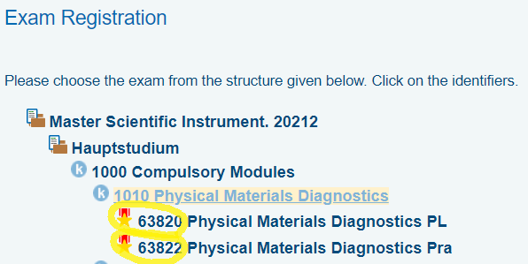It is important that you give the correct examination number. You find the examination number in the self-service-portal, as you can see on the screenshot below (The examination numbers are highlighted with yellow).